Karnataka Law Society’s

**GOGTE INSTITUTE OF TECHNOLOGY**

Udyambag Belgaum – 590008

**“Basic Electrical & Electronics Engineering”**



**Department of Electrical and Electronics**

A Project Report on

**“Transformers”**

Submitted by

|  |  |  |  |  |
| --- | --- | --- | --- | --- |
| S.No. | NAME | USN | ROLL NO. | SIGNATURE |
| 1 | RAHUL K | GIT19EC107-T | 1311 |  |
| 2 | MIHIR P | GIT19EE020-T | 1317 |  |
| 3 | VENKATESH D | GIT19CS144-T | 1339 |  |
| 4 | ATREAY K | GIT19CS180-T | 1354 |  |

Submitted to: Mr. P. G. Devalatkar

**Introduction:**

A **transformer** is a passive electrical device that transfers electrical energy between two or more [circuits](https://en.wikipedia.org/wiki/Electrical_network). A varying current in one coil of the transformer produces a varying [magnetic flux](https://en.wikipedia.org/wiki/Magnetic_flux), which, in turn, induces a varying [electromotive force](https://en.wikipedia.org/wiki/Electromotive_force) across a second coil wound around the same core. Electrical energy can be transferred between the two coils, without a metallic connection between the two circuits. [Faraday's law of induction](https://en.wikipedia.org/wiki/Faraday%27s_law_of_induction) discovered in 1831 described the induced voltage effect in any coil due to changing magnetic flux encircled by the coil.

Transformers are used for increasing or decreasing the alternating voltages in electric power applications, and for coupling the stages of signal processing circuits.

Generator step-up (GSU) transformers represent the second largest capital investment in Reclamation power production—second only to generators. Reclamation has hundreds, perhaps thousands, of transformers, in addition to hundreds of large GSU transformers. Reclamation has transformers as small as a camera battery charger, about one-half the size of a coffee cup, to huge generator step-up transformers near the size of a small house. The total investment in transformers may well exceed generator investment. Transformers are extremely important to Reclamation, and it is necessary to understand their basic functions.

A transformer has no internal moving parts, and it transfers energy from one circuit to another by electromagnetic induction. External cooling may include heat exchangers, radiators, fans, and oil pumps. Radiators and fans are evident in figure 1. The large horizontal tank at the top is a conservator. Transformers are typically used because a change in voltage is needed. Power transformers are defined as transformers rated 500 kVA and larger. Larger transformers are oil-filled for insulation and cooling; a typical GSU transformer may contain several thousand gallons of oil. One must always be aware of the possibility of spills, leaks, fires, and environmental risks this oil poses. Transformers smaller than 500 kVA are generally called distribution transformers. Pole-top and small, pad-mounted transformers that serve residences and small businesses are typically distribution transformers. Generator step-up transformers, used in Reclamation power plants, receive electrical energy at generator voltage and increase it to a higher voltage for transmission lines. Conversely, a step-down transformer receives energy at a higher voltage and delivers it at a lower voltage for distribution to various loads. All electrical devices using coils (in this case, transformers) are constant wattage devices. This means voltage multiplied by current must remain constant; therefore, when voltage is “stepped-up,” the current is “stepped-down” (and vice versa). Transformers transfers electrical energy between circuits completely insulated from each other. This makes it possible to use very high (stepped-up) voltages for transmission lines, resulting in a lower (stepped-down) current. Higher voltage and lower current reduce the required size and cost of transmission lines and reduce transmission losses as well. Transformers have made possible economic delivery of electric power over long distances. Transformers do not require as much attention as most other equipment; however, the care and maintenance they do require is absolutely critical. Because of their reliability, maintenance is sometimes ignored, causing reduced service life and, at times, outright failure.

**Principle of Operation:**

Transformer function is based on the principle that electrical energy is transferred efficiently by magnetic induction from one circuit to another. When one winding of a transformer is energized from an alternating current (AC) source, an alternating magnetic field is established in the transformer core. Alternating magnetic lines of force, called “flux,” circulate through the core. With a second winding around the same core, a voltage is induced by the alternating flux lines. A circuit, connected to the terminals of the second winding, results in current flow. Each phase of a transformer is composed of two separate coil windings wound on a common core. The low-voltage winding is placed nearest the core; the high-voltage winding is then placed around both the low voltage winding and core. See figure which shows internal construction of one phase. The core is typically made from very thin steel laminations, each coated with insulation. By insulating between individual laminations, losses are reduced. The steel core provides a low resistance path for magnetic flux. Both high- and low-voltage windings are insulated from the core and from each other, and leads are brought out through insulating bushings.

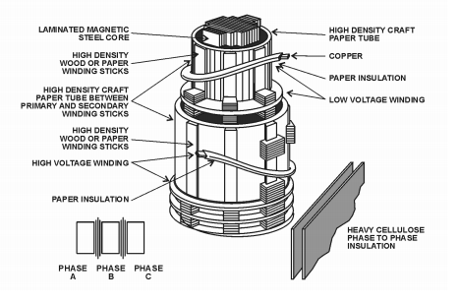

A three-phase transformer typically has a core with three legs and has both high-voltage and low-voltage windings around each leg. Special paper and wood are used for insulation and internal structural support.

**Types of Transformer:**

Transformers can be classified on different basis, like types of construction, types of cooling etc.  
  
***(A) On the basis of construction***, transformers can be classified into two types as;

1. Core type transformer
2. Shell type transformer, which are described below.

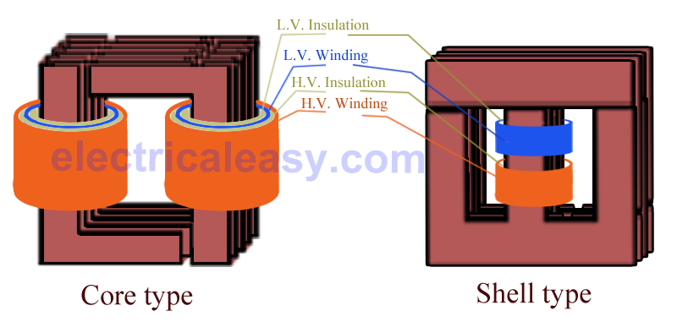

**(I) Core Type Transformer**

In core type transformer, windings are cylindrical former wound, mounted on the core limbs as shown in the figure above. The cylindrical coils have different layers and each layer is insulated from each other. Materials like paper, cloth or mica can be used for insulation. Low voltage windings are placed nearer to the core, as they are easier to insulate.

**(II) Shell Type Transformer**

The coils are former wound and mounted in layers stacked with insulation between them. A shell type transformer may have simple rectangular form (as shown in above fig), or it may have a distributed form.  
  
***(B) On the basis of their purpose***

1. Step up transformer: Voltage increases (with subsequent decrease in current) at secondary.
2. Step down transformer: Voltage decreases (with subsequent increase in current) at secondary.

**(C) On the basis of type of supply**

1. Single phase transformer
2. Three phase transformer

**(D) On the basis of their use**

1. Power transformer: Used in [transmission network](http://www.electricaleasy.com/2016/03/basics-of-electrical-power-transmission.html), high rating
2. Distribution transformer: Used in [distribution network](http://www.electricaleasy.com/2018/01/electric-power-distribution-system.html), comparatively lower rating than that of power transformers.
3. Instrument transformer: Used in relay and protection purpose in different instruments in industries
   * Current transformer (CT)
   * Potential transformer (PT)

**(E) On the basis of cooling employed**

1. Oil-filled self-cooled type
2. Oil-filled water cooled type
3. Air blast type (air cooled)

**Construction:**

Basically a transformer consists of two inductive windings and a laminated steel core. The coils are insulated from each other as well as from the steel core. A transformer may also consist of a container for winding and core assembly (called as tank), suitable bushings to take the terminals, oil conservator to provide oil in the transformer tank for cooling purposes etc. The figure at left illustrates the basic construction of a transformer.

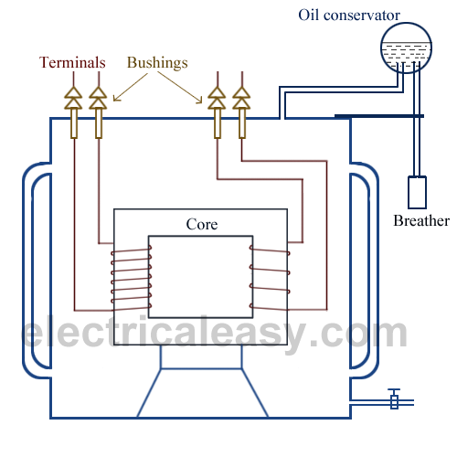

 In all types of transformers, core is constructed by assembling (stacking) laminated sheets of steel, with minimum air-gap between them (to achieve continuous magnetic path). The steel used is having high silicon content and sometimes heat treated, to provide high permeability and low hysteresis loss. Laminated sheets of steel are used to reduce eddy current loss. The sheets are cut in the shape as E, I and L. To avoid high reluctance at joints, laminations are stacked by alternating the sides of joint. That is, if joints of first sheet assembly are at front face, the joints of following assemble are kept at back face.

[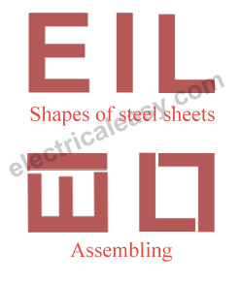](https://1.bp.blogspot.com/-hFxWSfRx9Y4/UyWZxWs5x9I/AAAAAAAAApQ/6CCIrBuupGc/s1600/transformer+E,I,L.png)

**Transformer Action:**

Transformer action depends upon magnetic lines of force (flux) mentioned above. At the instant a transformer primary is energized with AC, a flow of electrons (current) begins. During the instant of switch closing, build-up of current and magnetic field occurs. As current begins the positive portion of the sine wave, lines of magnetic force (flux) develop outward from the coil and continue to expand until the current is at its positive peak. The magnetic field is also at its positive peak. The current sine wave then begins to decrease, crosses zero, and goes negative until it reaches its negative peak. The magnetic flux switches direction and also reaches its peak in the opposite direction. With an AC power circuit, the current changes (alternates) continually 60 times per second, which is standard in the United States. Other countries may use other frequencies. In Europe, 50 cycles per second is common. Strength of a magnetic field depends on the amount of current and number of turns in the winding. When current is reduced, the magnetic field shrinks. When the current is switched off, the magnetic field collapses. When a coil is placed in an AC circuit, current in the primary coil will be accompanied by a constantly rising and collapsing magnetic field. When another coil is placed within the alternating magnetic field of the first coil, the rising and collapsing flux will induce voltage in the second coil. When an external circuit is connected to the second coil, the induced voltage in the coil will cause a current in the second coil. The coils are said to be magnetically coupled; they are, however, electrically isolated from each other. Many transformers have separate coils, and contain many turns of wire and a magnetic core, which forms a path for and concentrates the magnetic flux. The winding receiving electrical energy from the source is called the primary winding. The winding which receives energy from the primary winding, via the magnetic field, is called the “secondary” winding. Either the high- or low-voltage winding can be the primary or the secondary. With GSUs at Reclamation power plants, the primary winding is the low-voltage side (generator voltage), and the high-voltage side is the secondary winding (transmission voltage). Where power is used (i.e., at residences or businesses), the primary winding is the high-voltage side, and the secondary winding is the low-voltage side.

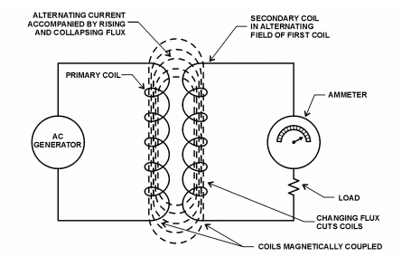

The amount of voltage induced in each turn of the secondary winding will be the same as the voltage across each turn of the primary winding. The total amount of voltage induced will be equal to the sum of the voltages induced in each turn. Therefore, if the secondary winding has more turns than the primary, a greater voltage will be induced in the secondary; and the transformer is known as a step-up transformer. If the secondary winding has fewer turns than the primary, a lower voltage will be induced in the secondary; and the transformer is a step-down transformer. Note that the primary is always connected to the source of power, and the secondary is always connected to the load. In actual practice, the amount of power available from the secondary will be slightly less than the amount supplied to the primary because of losses in the transformer itself.

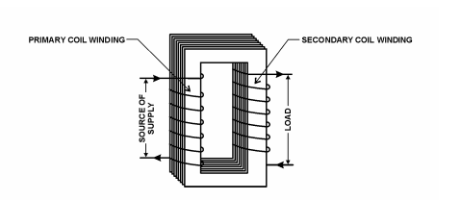

When an AC generator is connected to the primary coil of a transformer, electrons flow through the coil due to the generator voltage. Alternating current varies, and accompanying magnetic flux varies, cutting both transformer coils and inducing voltage in each coil circuit. The voltage induced in the primary circuit opposes the applied voltage and is known as back voltage or back electro-motive-force (back EMF). When the secondary circuit is open, back EMF, along with the primary circuit resistance, acts to limit the primary current. Primary current must be sufficient to maintain enough magnetic field to produce the required back EMF. When the secondary circuit is closed and a load is applied, current appears in the secondary due to induced voltage, resulting from flux created by the primary current. This secondary current sets up a second magnetic field in the transformer in the opposite direction of the primary field. Thus, the two fields oppose each other and result in a combined magnetic field of less strength than the single field produced by the primary with the secondary open. This reduces the back voltage (back EMF) of the primary and causes the primary current to increase. The primary current increases until it re-establishes the total magnetic field at its original strength.

In transformers, a balanced condition must always exist between the primary and secondary magnetic fields. Volts times amperes (amps) must also be balanced (be the same) on both primary and secondary. The required primary voltage and current must be supplied to maintain the transformer losses and secondary load.

### **Energy losses:**

Transformer energy losses are dominated by winding and core losses. Transformers' efficiency tends to improve with increasing transformer capacity. The efficiency of typical distribution transformers is between about 98 and 99 percent.

As transformer losses vary with load, it is often useful to tabulate no-load loss, full-load loss, half-load loss, and so on. Hysteresis and [eddy current](https://en.wikipedia.org/wiki/Eddy_current) losses are constant at all load levels and dominate at no load, while winding loss increases as load increases. The no-load loss can be significant, so that even an idle transformer constitutes a drain on the electrical supply. Designing [energy efficient transformers](https://en.wikipedia.org/wiki/Energy_efficient_transformer) for lower loss requires a larger core, good-quality [silicon steel](https://en.wikipedia.org/wiki/Electrical_steel), or even [amorphous steel](https://en.wikipedia.org/wiki/Electrical_steel#Amorphous_steel) for the core and thicker wire, increasing initial cost. The choice of construction represents a [trade-off](https://en.wikipedia.org/wiki/Trade-off) between initial cost and operating cost.

Transformer losses arise from:

**Winding joule losses:**

Current flowing through a winding's conductor causes [joule heating](https://en.wikipedia.org/wiki/Joule_heating) due to the [resistance](https://en.wikipedia.org/wiki/Electrical_resistance) of the wire. As frequency increases, skin effect and [proximity effect](https://en.wikipedia.org/wiki/Proximity_effect_(electromagnetism)) causes the winding's resistance and, hence, losses to increase.

[**Core losses**](https://en.wikipedia.org/wiki/Magnetic_core#Core_loss) **:**

**Eddy current losses:**

[Eddy currents](https://en.wikipedia.org/wiki/Eddy_current) are induced in the conductive metal transformer core by the changing magnetic field, and this current flowing through the resistance of the iron dissipates energy as heat in the core. The eddy current loss is a complex function of the square of supply frequency and inverse square of the material thickness. Eddy current losses can be reduced by making the core of a stack of laminations (thin plates) electrically insulated from each other, rather than a solid block; all transformers operating at low frequencies use laminated or similar cores.

**Magnetostriction related transformer:**

Magnetic flux in a ferromagnetic material, such as the core, causes it to physically expand and contract slightly with each cycle of the magnetic field, an effect known as [magnetostriction](https://en.wikipedia.org/wiki/Magnetostriction), the frictional energy of which produces an audible noise known as [mains hum](https://en.wikipedia.org/wiki/Mains_hum) or "transformer hum". This transformer hum is especially objectionable in transformers supplied at [power frequencies](https://en.wikipedia.org/wiki/Utility_frequency) and in [high-frequency](https://en.wikipedia.org/wiki/High-frequency) [fly back transformers](https://en.wikipedia.org/wiki/Flyback_transformer) associated with television [CRTs](https://en.wikipedia.org/wiki/Cathode_ray_tube).

**Stray losses:**

Leakage inductance is by itself largely lossless, since energy supplied to its magnetic fields is returned to the supply with the next half-cycle. However, any leakage flux that intercepts nearby conductive materials such as the transformer's support structure will give rise to eddy currents and be converted to heat.

**Hysteresis losses:**

Hysteresis loss is due to the reversal of magnetization of transformer core whenever it is subjected to alternating nature of magnetizing force. Whenever the core is subjected to an alternating magnetic field, the domain present in the material will change their orientation after every half cycle. The power consumed by the magnetic domains for changing the orientation after every half cycle is called Hysteresis loss.

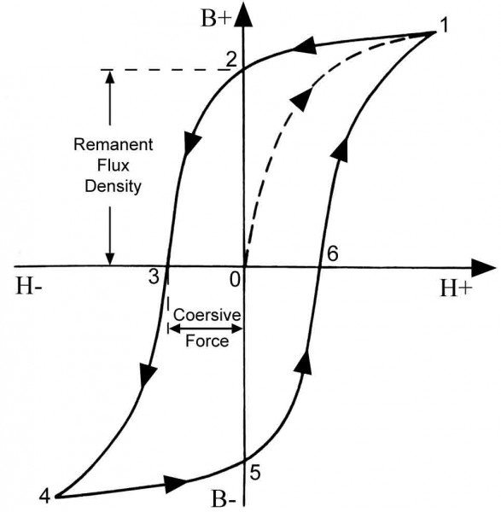

If you look at the B-H curve then you will observe that on the X-axis, even if the current becomes zero. The material is still containing some amount of flux, which is known as Retentivity. The material has a property to retain some flux and to make that flux zero, a cohesive force is applied. That extra force that is applied is nothing but the Hysteresis loss.

**Applications:**

Various specific electrical application designs require a variety of [transformer types](https://en.wikipedia.org/wiki/Transformer_types). Although they all share the basic characteristic transformer principles, they are customized in construction or electrical properties for certain installation requirements or circuit conditions.

In [electric power transmission](https://en.wikipedia.org/wiki/Electric_power_transmission), transformers allow transmission of electric power at high voltages, which reduces the loss due to heating of the wires. This allows generating plants to be located economically at a distance from electrical consumers. All but a tiny fraction of the world's electrical power has passed through a series of transformers by the time it reaches the consumer.

In many electronic devices, a transformer is used to convert voltage from the distribution wiring to convenient values for the circuit requirements, either directly at the power line frequency or through a [switch mode power supply](https://en.wikipedia.org/wiki/Switch_mode_power_supply).

Signal and audio transformers are used to couple stages of [amplifiers](https://en.wikipedia.org/wiki/Amplifier) and to match devices such as [microphones](https://en.wikipedia.org/wiki/Microphone) and [record players](https://en.wikipedia.org/wiki/Record_player) to the input of amplifiers. Audio transformers allowed [telephone](https://en.wikipedia.org/wiki/Telephone) circuits to carry on a [two-way conversation](https://en.wikipedia.org/wiki/Hybrid_coil) over a single pair of wires. A [balloon](https://en.wikipedia.org/wiki/Balun) transformer converts a signal that is referenced to ground to a signal that has [balanced voltages to ground](https://en.wikipedia.org/wiki/Balanced_line), such as between external cables and internal circuits. Isolation transformers prevent leakage of current into the secondary circuit and are used in medical equipment and at construction sites. Resonant transformers are used for coupling between stages of radio receivers, or in high-voltage Tesla coils.

**References:**

1. **E. Hughes, “Electrical Technology”, International Students 9th Edition Pearson, 2005.**
2. **V. K. Mehta and Rohit Mehta, “Basic Electrical Engineering”, S. Chand Publications,2010.**
3. **Robert Boylston, “Electronic Devices and Circuits theory”, Pearson Education,9th edition,2005.**